‘

Pediatric Urine Collection by Urinary Bag (U-Bag)
- Separate the legs of the child.
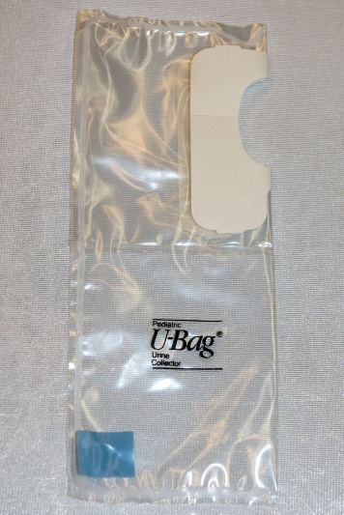
- Wash the perineum (area between the anus and the scrotum or vulva) with soap and water and dry well.
- Do not use powder, oil, or lotion on the skin.
- Remove the backing from the lower part of the adhesive patch
- Remove folds in the child’s skin by gently stretching the child’s skin
- Place the narrowest section of the adhesive against the perineum, ensuring that it sticks
- Smooth the remaining adhesive against the skin, pressing firmly to avoid wrinkles
- Remove the backing from the top part of the adhesive and smooth adhesive against the skin above the penis or the vagina
- Frequently check the collection bag and remove once urine has collected in it.
- Multiple attempts at collection may be required.
- When the collection is complete, gently peel the adhesive back from the skin and drain urine into sterile container.

